**Unit 9 Can you come to my party?**

**教学目标与要求**

话题：邀请（Invitations）

功能：

1 能发出、接受或拒绝邀请（Make, accept and decline invitations）

A: Can you come to my party on Saturday?

B: Sure, I’d love to./ Sorry, I must study for a math test.

2 能使用have to, must来谈论职责和义务（Talk about obligations）

A: Can you come to my party on Saturday afternoon?

B: Sorry, I can’t. I have to prepare for an exam.

C: I’m sorry, too. I must go to the doctor.

语法：

1 能正确使用can引导的句子表达邀请（Can for invitations）

A: Can you play tennis with me?

B: Sure, I’d love to.

A: Sure. That sounds great./ I’m afraid not. I have the flu.

词汇和常用表达：

1 能够正确使用下列词汇（Curriculum words）

exam, flu, weekday, invitation, preparation, glue, opening, concert, event, guest, calendar, daytime, prepare, hang, catch, invite, accept, refuse, reply, forward, delete, print, available, sad, glad, surprised, without, until, goodbye

2 能够正确使用下列常用表达（Useful expressions）

prepare for, hang out, look after, look forward to, another time, not…until, the day before yesterday, the day after tomorrow, turn down, take a trip, hear from

语音：

能正确读出句子重音，并能运用词汇重读表达不同句子意思。

学习策略：

1 通过体验学会用得体的语言发出、接受或拒绝别人的推荐，并能陈述自己的理由，监控交际语言运用的得体性

2 在阅读中，掌握通过对比分析等手段分析和解决问题

文化知识：

1 了解国外社交聚会的基本知识，以及出席此类聚会的基本常识

2 了解有关聚会邀请的礼仪，并知道如何接受邀请或委婉拒绝邀请

**Section A 1 (1a-2d)**

1. **教学目标：**

1) 学生能掌握以下单词：prepare for an exam, have the flue, help one’s parents, meet one’s friends, go to the/ a doctor, available, another time, go bike riding, not …until, hang out, catch

2) 学生能掌握以下句型：

① — Can you come to my party on Saturday afternoon?

— Sure, I’d love to.

② — Can you go to the movies on Saturday?

— I’m sorry, I’m not available. I have too much homework this weekend.

③ That’s too bad. Maybe another time.

④ Sure. Thanks for asking.

⑤ Sam isn’t leaving until next Wednesday.

3) 学生能了解以下语法：用情态动词can来表达邀请。

2. 让学生学会表达邀请，学会对邀请进行恰当的答复或拒绝。

3. 教学生学会人际交往的基本常识，学会有礼貌地邀请别人以及回答别人的邀请的方式。

二、**教学重难点**

1. 教学重点：

1) 运用所学提出邀请，接受邀请和拒绝邀请。

2) 正确使用can, might, must 等情态动词。

2. 教学难点：

1) 扎实掌握重点词汇和表示邀请的句型并能灵活运用。

2) 运用得体的语言对接受或拒绝邀请进行合理的表达并能陈述原因。

**三、教学步骤**

**Ⅰ. Lead-in**

在大屏幕上创设场景引入对话讨论。

T: I’m really busy on weekdays. I need to relax on weekends. What can I do to relax?

S: You can go shopping.

S: You can go to the movies.

S: You can …

T: New Year’s Day is coming. I’m going to have a New Year’s Party at home. Can you come to my party?

S: Yes, I’d love to./ Sorry, I have to…

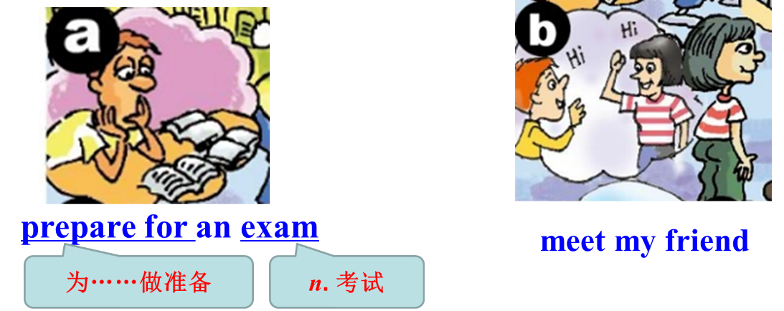

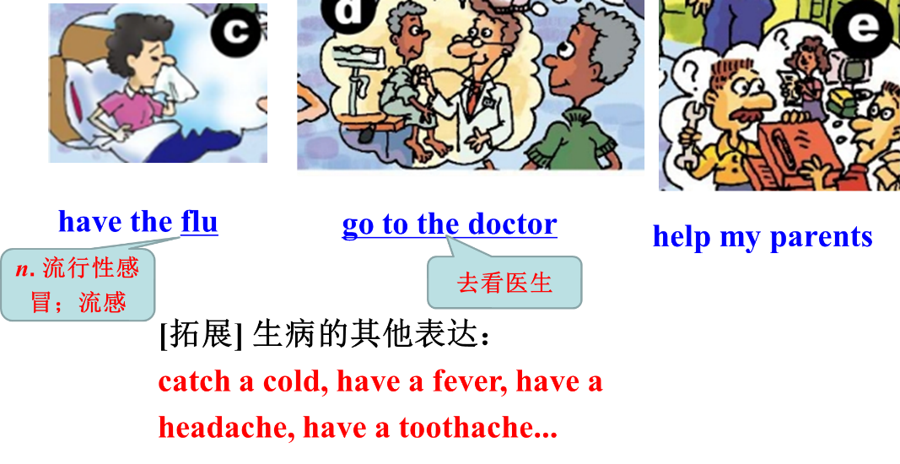



– Can you come to my party?

– Sure , I’d love to.

– That sounds great /good.

– That would be nice.



– Can you come to my party? 

– Sorry, I can’t .

I have to…

I must…

I am going to…

– Sorry, I can’t . I have the flu, I must /have to go to the doctor.

– Sorry, I can’t . I am going to see a doctor.



– Can you watch a basketball match with me? 

– Sure, I’d love/like to.

– That sounds great /good.

– That would be nice.



– Can you go shopping with me tomorrow? 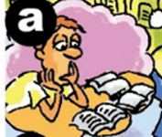

– Sorry, I can’t. I have to/must prepare for an exam.

– Sorry, I’m afraid not. I’m going to prepare for an exam.



– Can you come to my party this Sunday?

– Sorry, I can’t. I have to/ must go to the doctor.

– Sorry, I’m afraid not. I’m going to see the doctor.

.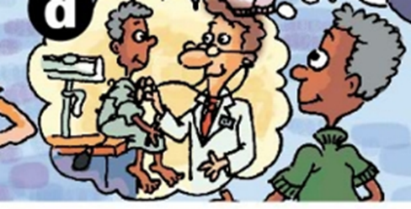

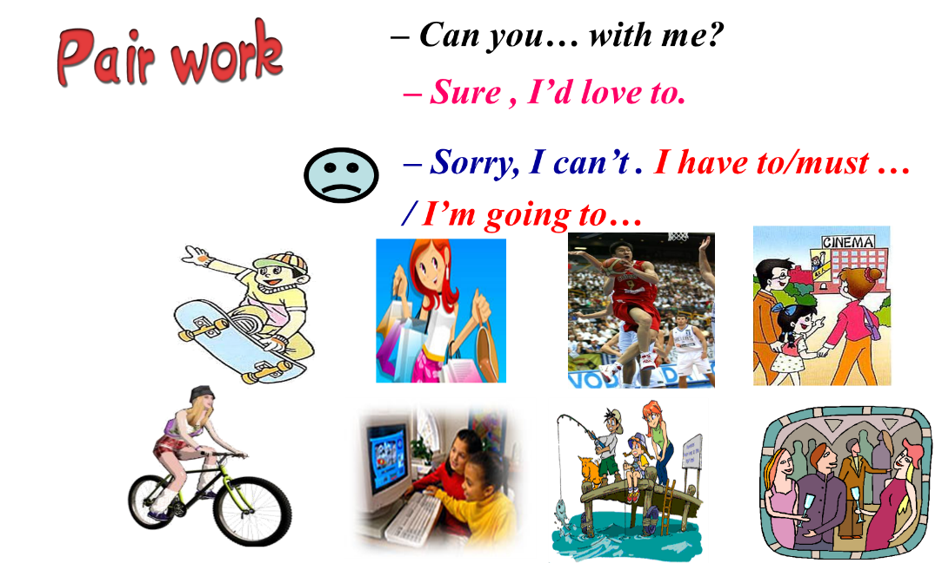

**Ⅱ. Work on 1a**

T: Match the phrases with the pictures (a-e).

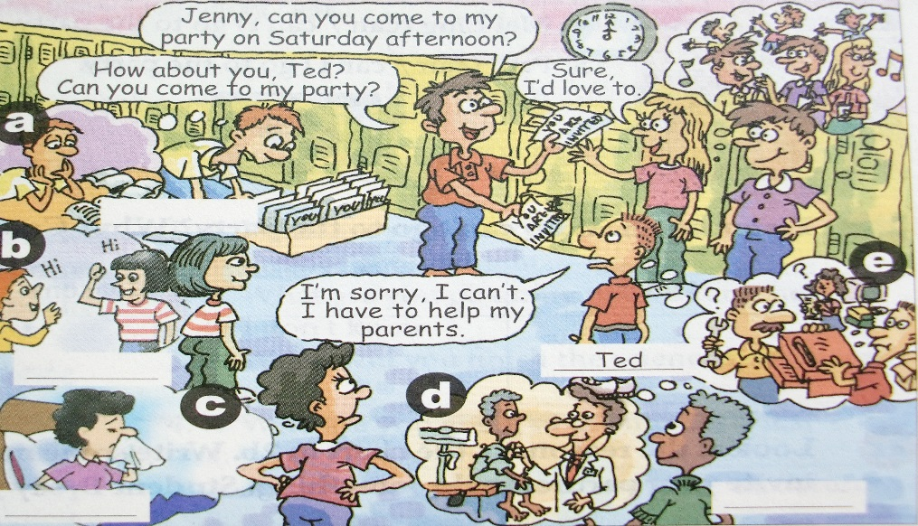

1. prepare for an exam ______

2. help my parents ______

3. go to the doctor ______

4. meet my friend ______

5. have the flu ______

**III. Listening**

Work on 1b



1. T: Now listen to the recording and write the names next to the correct students in the picture.

2. Play the recording for the first time. Students only listen. Play the recording the second time. Write the name of each person next to his or her picture.

3. Play the recording and show the table to Ss.

|  |  |
| --- | --- |
| Names | Reasons |
| Ted | He has to help his parents. |
| Tim | He has to ______________________. |
| Wilson | He must _______________. |
| Anna | She might have to _______________. |
| Kay | She ______________. |

4. Play the recording again. Ask Ss to pay attention to how to make, accept and decline the invitation.

5. Role-play the conversation and pay attention to how to make, accept and decline the invitation.

Sun Ning: Hey, Ted. Can you come to my party on Saturday afternoon?

Ted: I’m sorry, I can’t, Sun Ning. I have to help my parents.

Sun Ning: Too bad. How about you, Jenny? Can you come to my party?

Jenny: I’d love to.

Sun Ning: Tim? What about you?

Tim: When is it?

Sun Ning: Saturday afternoon.

Tim: Oh, no, I can’t. I have to prepare for an exam.

Sun Ning: What about you, Wilson?

Wilson: Sorry, I must go to the doctor.

Sun Ning: Anna, can you come?

Anna: I can’t, Sun Ning. I might have to meet my friend.

Kay: I can’t either, Sun Ning. I have the flu.

Sun Ning: That’s too bad, Kay. Oh, maybe next time. What a small party!

Conclusion:

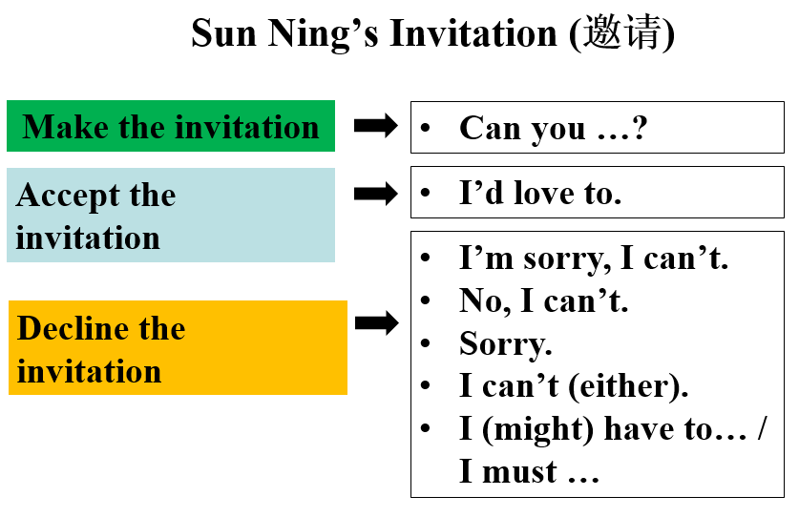

**IV. Group work**

Work on 1c.

Let some groups ask and answer according to picture in 1a.

**V. Listening**

Work on 2a:

|  |
| --- |
| 1. Jeff (can / can’t ) go to the party.  2. Mary (can / can’t) go to the party.  3. May (can / can’t) go to the party.  4. Mei Ling (can / can’t) go to the party.  5. Paul (can / can’t) go to the party. |

1. Read the sentences in 2a. Tell Ss they will listen to some sentences. They should listen and circle the words “can” or “can’t” in the bracket.

2. Play the recording for the Ss to listen and circle the words.

3. Play the recording again to check the answers.

Work on 2b:

|  |  |
| --- | --- |
| Names | Reasons |
|  |  |

1. Tell Ss this time they must write the reasons in the chart. Make sure they know what to do.

2. Play the recording for the Ss to write the reasons in the chart.

3. Play the recording again to check the answers.

4. Listen again and match the names and answers.

Jeff I'd love to.

Mary I'm afraid not.

May Sure. It sounds great.

Mei Ling I'm sorry. I'm not free.

Paul Sorry, but I’m not available (= free).

5. Listen the conversations and role-play them.

Conversation 1

Anna: Hi, Jeff! Can you come to my party on Saturday?

Jeff: I’m sorry, I’m not free. I might have to meet my friend on Saturday.

Conversation 2

Anna: Hello, Mary! Can you come to my party on Saturday?

Mary: I’d love to. Do I need to bring anything?

Anna: No, I’ll buy all the food and drinks.

Conversation 3

Anna: May, can you come to my party tomorrow?

May: I’m afraid not. I have the flu.

Anna: Oh, that’s too bad. Well, drink lots of hot water and get lots of sleep.

Conversation 4

Anna: Mei Ling, can you come to my party on Saturday?

Mei Ling: Sorry, but I’m not available. I must study for a math test.

Anna: OK. Good luck!

Conversation 5

Anna: Hey, Paul. Can you come to my party on Saturday?

Paul: Sure. It sounds great. When will it start?

Anna: Around 6:00 p.m. See you then.

Paul: See you.

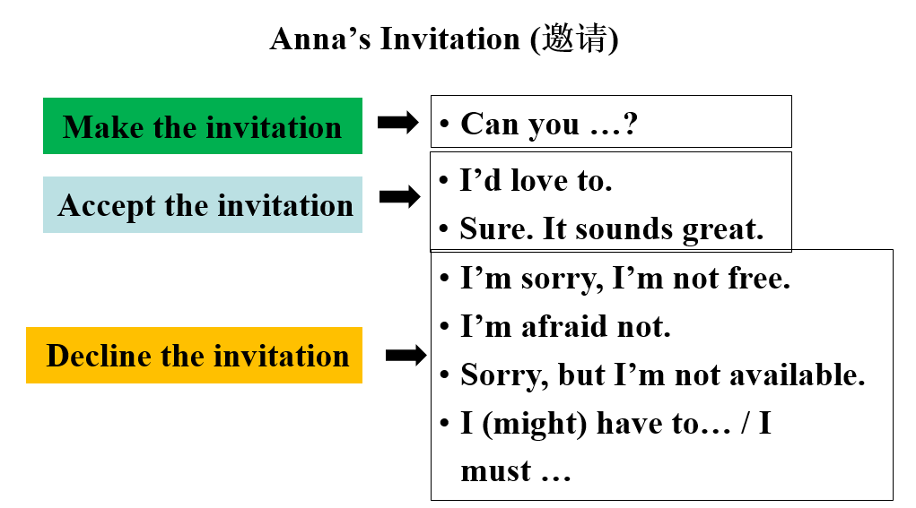

礼貌地发出邀请：

Can you come to…?

Could you come to my party?

Would you like to come to my party?

接受邀请：

Sure, I’d love to.

Sure, it sounds great.

…

委婉拒绝邀请：

Sorry, I can’t. I have to …

I’m sorry. I must ...

I’m sorry. I’m not available. I have ...

I’d love to come, but I’m afraid I can’t. I have ...

**VI. Pair work**

1. Tell Ss to look at the reasons in the chart in 2b. Then write some more.

2. Let Ss read conversations in 2c.

3. Ss practice the conversations using the reasons in the chart on the right.

4. Ask some pairs to act out their conversations.

**VII. Work on 2d**

1. T: Listen and read the conversation then answer the questions.

1) Why did Jeff invite Nick to his house?

2) Did Nick accept the invitation at first? Why?

3) Did Nick accept the invitation at last? Why?

2. Let Ss practice the conversation with their partners. Then let some pairs act out the

conversation.

3. Fill in the blanks according to the conversation.

Jeff’s _______ Sam _____ Xi’an is going to visit him on Saturday. Jeff and his

friend Nick _____ bike riding together last fall when Sam came. But this

Saturday Nick _____ come to Jeff’s house because he ____ _______ ____ an

exam on Monday. Luckily, Sam isn’t leaving ______ next Wednesday. Nick

can ______ them on Monday and then _____ ____ together on Monday night.

**VIII. Language points**

1. Jenny, can you come to my party on Saturday afternoon?

珍妮，周六下午你能来参加我的聚会吗？

Can you…? 你能……吗？

这是一个发出邀请的重要句式。如果想更礼貌地发出邀请，还可以使用“Could you…?”或“Would you like to…”等句式。

接受邀请常用“Sure, I’d love to. (当然了，我愿意)”

“Certainly. (当然可以)”或 “No problem. (没问题)”回答。

委婉拒绝邀请常用 “Sorry, I can’t (对不起，我不能)” 或 “I’d love to, but… (我很愿意，但是……)”回答。

e.g. – Can you come to my home this Friday?

这周五你能来我家吗？

– Sure, I’d love to. 当然了，我很愿意。/ I’d love to, but I have to see the dentist that day. 我愿意去，但是那天我不得不去看牙医。

on Saturday afternoon 在周六下午

相当于on the afternoon of Saturday。在具体的某一天或某一天的上午、下午或晚上前，用介词on。

on the morning of May 1st 在五月一日上午

on Monday evening 在周一晚上

拓展

在英语中，at和in也可以用于时间前，表示“在……”，具体用法如下：

(1) at用于时刻前，以及一些固定短语中。

at 10:10 在10点10分 at noon 在中午

at night 在晚上

(2) in 用于世纪、年、季节、月份前，也可泛指在上午、下午或晚上。

in 2022 在2022年 in autumn 在秋天

in January 在1月 in the morning 在上午

【助记】

时间介词on, at与in的用法

on后具体某一天，日期、星期、节日前。

at用在时刻前，也与正午、午夜连。

月份、季节与年份，in必须用在其前面。

中考链接

1. 16. We’ll have a class meeting ________ 3:30 this afternoon.

A. in B. on C. at

(2021山东临沂中考)

2. China’s first Mars rover, Zhurong, touched down on the Red Planet _______ May 15, 2021.

A. on B. in C. at D. to

(2021江苏扬州中考)

Keys: 1. C 2. A

2. Sure, I’d love to. 当然了，我愿意去。

I’d love to 我愿意

与I’d like to同义，常用来愉快地答应对方的请求、提议或邀请，其中的to不能省略。

e.g. –Can you go to the new supermarket with me?

你能和我一起去机关报超市吗？

– Sure, I’d love/ like to. 当然，我很乐意。

3. have the flu 患流感

have a/ an+表示疾病的名词，得……病；而have the flu前不用a，只用the。

e.g. She didn’t go to school because she had the flu.

她没去上学，因为她得了流感。

拓展

表示“患病”的常用短语

have a cold 感冒 have a cough 咳嗽

have a fever 发烧 have a sore throat 喉咙痛

have a headache 头痛 have a toothache 牙痛

4. I’m sorry. I’m not available.

对不起，我没有空。

available *adj*. 有空的 常作表语。其同义词为free，反义词为busy或full。

e.g. – Are you available tomorrow morning?

明天早上你有空吗？

– No, I’m full. 没有，我很忙。

available *adj*. 可用的；可获得的

e.g. This is the only room available.

这是唯一可用的房间。

【语境应用】单项选择。

—Miss Yang, are you ______ this afternoon? I'd like to ask you some questions.

—Yes, I will wait for you in my office.

A. afraid B. available

C. absent D. active

afraid害怕的； available有空的；absent缺席的；active活跃的

key: B

5. I have to prepare for an exam. 我要准备考试。

prepare *v*. 使做好准备；把……准备好

常用结构:

prepare for sth. 为某事做准备

prepare to do sth. 准备做某事

prepare sb. sth. / prepare sth. for sb. 为某人准备某物

【拓展】

preparation *n.* 准备；准备工作

常用短语:

make preparations for sth. 为某事做准备

【语境应用】完成句子。

1) 我们正在努力工作，为会议做准备。

We are working hard to ____________________________.

2) 我准备写一些关于我旅行的事。

________________________ write something about my trip.

3) 当你去香港时，我正忙着准备期末考试。(prepare)

While you were on the visit to Hong Kong, I was busy _______________ my final exams.

Keys: 1) prepare for the meeting 2) I prepare to 3) preparing for

6. Oh, but Sam isn’t leaving until next Wednesday.

哦，但是萨姆要一直待到下周三才会走。

until *prep*. 到……时；直到……为止 相当于till。

e.g. Go down the street until you see the bank.

一直走，直到你看见银行。

not … until … 直到……才…… 句中谓语动词 常为非延续性动词，指until

所表示的时间到了，该动作才发生。在肯定句中，谓语动词常为延续性动词，

表示该动作一直持续到until所表示的时间为止。

e.g. The famous actor didn’t appear until 8:00 p.m.

那位著名的演员直到晚上8点才出现。

They will stay on the space station until next.

他们将在太空站待到下周五。

until *conj*. 到……时，直到……为止

引导时间状语从句。用于肯定句时，主句谓语动词常为延续性动词或表示状态的动词或短语，表示主句的动作、状态持续到until引导的从句动作或状态出现之时， “直到……为止”；until用于否定句时，构成not… until结构 “直到……才”，此时主句谓语动词常为非延续性动词，表示直到until从句所表示的动作出现时主句动作才发生。

e.g. He lived with his parents until he got married.

他与父母住在一起直到结婚。

I won’t believe you until I see it myself.

直到我亲自看到它我才会相信你。

中考链接

In Chinese families, people won’t start dinner _______ the elders take their seats.

A. after B. when C. because D. until

(2020山东青岛中考)

Key: D

7. Can you hang out with us on Monday night?

周一晚上你能跟我们一起逛逛吗？

hang out 闲逛，常去某地 (常用于口语)

e.g. Let’s hang out for fun.

让我们出去玩吧。

hang *v*. (hung) 悬挂

e.g. Philip hung his coat on a hook behind the door.

Philip把自己的大衣挂在门后的钩子上。

【拓展】hang on 稍等；别挂电话

【语境应用】完成句子。

1) 请别挂电话。我有重要的事情要告诉你。

Please ________ ________. I have something important to tell you.

2) 我看见他正把上衣挂在架子上。

I ________ ________ ________ the coat on the shelf.

3) 我爷爷奶奶经常在晚饭后出去溜达。

My grandparents usually ________ ________ after dinner.

Keys: 1) hang on 2) saw him hanging 3) hang out

8. Catch you on Monday!

礼拜一见！

catch you 再见

这是英语中道别的又一种说法，相当于See you on Monday! 类似的说法还有: Catch / See you later! (回头见！)

e.g. – I’ll give you a call in a couple of days.

我过几天会给你打电话。

– Okay. Catch you later. 好的。再见

catch *v*. 及时赶上；接住；抓住

e.g. As long as you work hard, you will catch up with others.

只要努力学习，你就会赶上别人。

Cats like catching mice. 猫喜欢捉老鼠。

**IX. Summary**

____________________ 去看医生

_________________________ 备考

___________________ 患流感

help my parents _________________

meet my friends _________________

____________________ 在星期六下午

last fall ________________________

go bike riding ____________________

_______________ 闲逛；常去某处

礼貌地发出邀请：

Can you come to…?

Could you come to my party?

Would you like to come to my party?

接受邀请：

I’d love to.

Sure. It sounds great.

…

委婉拒绝邀请：

Sorry, I can’t. I have to …

I’m sorry. I’m not free then.

I’m sorry. I’m not available. I have ...

I’d love to come, but I’m afraid I can’t. I have ...

**X. Exercise**

**Ⅰ. 根据句意，从方框中选择恰当的单词填空, 注意形式变化。**

|  |
| --- |
| available, exam, catch, flu |

1. The police _______ that criminal in the town.

2. Will you be _______ this Sunday? I’d like to invite you to dinner.

3. I felt like I had the _______. I didn’t feel very well.

4. Jake did well in all the _______. He is going out to celebrate.

**Ⅱ. 根据句意及所给汉语提示，写出所缺内容，每空一词（含缩略形式）。**

1. I’m busy right now. Could you come back _______ _______ (其他时间)?

2. I _______ _______ _______ _______ (去看医生) yesterday. He said my illness (病) was not serious.

3. The students are busy _______ _______ (为……做准备) the goodbye party.

4. It is sunny, and I am happy to _______ _______ (闲逛) with my parents.

5. Yesterday, we _______ _______ _______ _______ (直到……才吃午饭) two o’clock.

**XI. Homework**

Use what you have learned in this lesson to make up a new conversation among three people. One makes an invitation, the second person accepts it and the third person turns down it.

**Section A 2 (Grammar Focus-3c)**

一、**教学目标：**

1. 1) 学生要掌握下列词汇：invite, accept, refuse

2）带领学生进行一步复习巩固运用Section A 1部分所学的生词和词组。

3）进一步教学生运用所学的知识来表达邀请；如何回答别人对自己的邀请，以及学会如何有礼貌地拒绝他人的邀请，并陈述理由。

4) 让学生掌握情态动词can, must, have to, might的用法。

2. 让学生学会人际交往的基本常识，学会有礼貌地邀请别人以及回答别人的邀请的方式。

二、**教学重难点**

1. 教学重点：

1) 进一步教学生运用所学的知识来表达邀请；有礼貌地答复他人对自己的邀请。

2) 让学生掌握情态动词can来表达邀请；运用情态动词have to, must, might等有礼貌地说明拒绝他人邀请的理由。

2. 教学难点：

1) 学生能否熟练进行邀请及应答。

2) 让学生能运用情态动词have to, must, might等有礼貌地说明拒绝他人邀请的理由。

**三、教学步骤**

**Ⅰ. Revision**

1.

1) 为考试而做准备 prepare for an exam

2) 看医生 go to the doctor

3) 上钢琴课 have a piano lesson

4) 帮助我的父母亲 help my parents

5) 拜访我的姑姑 visit my aunt

2. Ask Ss to invite some Ss to do some activities. The partners give some answers.

S1: Can you play tennis with me tomorrow afternoon?

S2: Sure. I’d love to.

S3: I’m afraid not. I have the flu.

S4: …

**Ⅱ. Grammar Focus.**

1. 学生阅读Grammar Focus中的句子，然后做填空练习。

① ─星期六你能来我的聚会吗？

─____ you _____ to my party on Saturday?

─当然，我乐意来。

─Sure, ____ _____ _____.

─对不起，我必须为数学考试备考。

─Sorry, I _____ _____ _____ a math test.

② ─ 明天晚上你能去看电影吗？

─ _____ you ____ to the movie ___________ night?

─当然可以，听起来很棒。

─ ______, that _______ ________.

─ 恐怕不行，我得了流感。

─ I’m ______ not. I have the ______.

③ ─ 他能参加聚会吗？

─ _____ he ______ to the party？

─ 不能。他必须帮助他的父母。

─ No, he ____. He _____ to help his parents.

④ ─ 她能去看棒球比赛吗？

─ ____ she go to the baseball _______?

─ 不，她没有空。她必须去看医生。

─ No, she’s _______ ________. She ______ ____ to the ______.

⑤ ─ 他们能去看电影吗？

─ _____ they____ to the _______？

─ 不，他们没有空。他们可能得去见朋友。

─ No, they’re not __________. They _____ ______ ____ meet their ________.

2. 学生完成填空试题后，可以打开课本检查答案，对错误的句子，单独进行强化记忆。

**Ⅲ. Grammar**

can表示请求和可能性

1. “Can you come to/ go to…?” can引起的问句可以表示委婉的请求或邀请，回答方式灵活多样，可根据具体情况作出礼貌回答。

如果接受邀请，答语可用Sure, I’d love to. / Sure, it sounds great等。

【拓展】

Yes, I’d love/like to.

Sure, that sounds great.

Certainly, I’d love/like to.

Sure, I’d love/like to.

Thanks for your invitation.

Thanks for asking me.

如果拒绝邀请，答语可用：

I’m sorry. I’m not free/available.

Thanks for your invitation. I might have to/must...

Sorry, I’m afraid not. I might have to/must...

Sorry, I can’t. I might have to/must...

I’d love to, but I have to…

No, I can’t. I’m going to ...

Thank you for asking me. But ....

I am afraid not, I...

【拓展】

其他提出邀请的句型：

Could/ Will you…?

Would you like to ...?

How/ What about ...?

Why not ...?

Let’s ...

I hope you ...

2. can表示“做某事的可能性”，意为“可以”(可用来询问打听第三方能否参加某项活动)。对这种情况下can引起的问句仍由can或can’t作肯定或否定回答。

如课本中的句子Can he go to the party?

肯定答语：Yes, he / she / they can.；

否定答语：No, he / she / they can’t. 或No, he / she is / they are not available.等。

e.g. —Can he come here before nine tomorrow morning?

—No, he can’t. He has to go to the music club first.

—Can Alice go to the movies with us tonight?

—Yes, she can. / No, she’s not available. She has to look after her sister.

might的用法

They might have to meet their friends.

might 在此表示推测和可能性。它的可能性比may小。

e.g. She might not want to come with us.

她可能不想和我们一起走。

中考链接

1. —What will the weather be like tomorrow?

—It ________ be rainy, cloudy or sunny. I am not sure.

A. must B. may C. can’t D. should

(2021辽宁朝阳中考)

2. —Can you play table tennis?

—Yes, I ______.

A. can B. must C. may

(2021广西桂林中考)

3. We____ have a graduation ceremony next week, but I'm not sure.

A. must B. need C. might

(2021黑龙江绥化中考)

Keys: CAC

**IV. Practice**

Work on 3a:

Tell Ss to read the conversation in 3a and try to complete the answers with might and

one of the phrases in the box.

|  |
| --- |
| watch TV, on the weekend, my cousin, visit my grandparents, practice the violin |

1. A: What are you going to do on Saturday?

B: I’m not sure. I might ________________________.

2. A: What are you planning to do after school?

B: I don’t know. ________________.

3. A: When will you finish the science homework?

B: _____________________________________________.

4. A: Who are you going to the movies with?

B: ______________________________________.

5. A: Are you free to come to my place on Saturday?

B: ______________________________________________.

Work on 3b:

1. Inviting: ____________________________ (can/play tennis)

Accepting: __________________________

2. Inviting: ____________________________ (would like to/go to the movies)

Refusing: __________________________

Reason: ____________________________

1) 告诉学生们本题的要求：根据括号中所给的提示词来补全问句，并做出恰当地答复。

2) 让学生们重点看答复提示中所要求是“接受”的还是“拒绝”的，并做答复。如果是拒绝，还应根据括号中的提示词给出一个恰当的理由。

3) 让学生们互相检查自己所写的小对话，发现并改正错误。

4) 让部分学生与自己的伙伴说一说自己所写的小对话。大家一起改正句子中的错误。

Work on 3c:

Ask Ss to write down everything they have to do the next week. Choose a day and time

to have a party.

|  |  |  |  |
| --- | --- | --- | --- |
|  | Morning | Afternoon | Evening |
| MON. |  |  |  |
| TUE. |  |  |  |
| WED. |  |  |  |
| THUR. |  |  |  |
| FRI. |  |  |  |
| SAT. |  |  |  |
| SUN. |  |  |  |

Invite your classmates to your party.

Example:

A: Can you come to my party?

B: When is it?

A: Next week, on Saturday evening.

B: I’m sorry. I have to study for a math test.

**V. Language points**

1. invite   *v.* 邀请

常用短语：

invite sb. to some place 邀请某人到某地

invite sb. to do sth.   邀请某人做某事

【拓展】invitation *n.* 邀请；请柬

与invitation相关的短语有：

make an invitation  发出邀请

accept an invitation  接受邀请

turn down / refuse an invitation  拒绝邀请

【语境应用】把下面的汉语句子翻译成英语。

1) 我邀请Jenny去看电影。

____________________________________

2) 我经常收到参加晚会的邀请。

____________________________________

I invite Jenny to go to the cinema.

I often get invitations to the party.

补全对话。

A: Hi, Jane! Why didn't you go to Ann's party yesterday?

B: I didn't feel well, so I had to (1)_____________________ (拒绝她的邀请). Did she (2)_______________________ (邀请你参加她的派对)?

A: Yes. At the party, a beautiful girl (3) ___________________________ (邀请我和她唱歌) .

B: Really? Sounds fun!

A: Ha ha ... After the party, Ann (4) ______________________________ (邀请我们去一家新电影院) and we watched an interesting movie.

B: You really had a good time.

refuse her invitation invite you to her party

invited me to sing with her  invited us to a new movie theater

2. refuse *v*. 拒绝 (后面常接名词、代词或动词不定式)，不能接动词-ing形式作宾语。

refuse to do sth. 拒绝做某事

e.g. Lily refused David’s invitation.

The old woman never refuses to help others.

【语境应用】下面句子中的划线部分有一处错误，请指出并改正。

Ann refused playing with her friend because she had to do her homework.

to play

翻译句子。

1) 我拒绝了王丽的邀请。

______________________________________

2) 你最好不要拒绝帮助别人。

______________________________________

I refused Wang Li’s invitation.

You’d better not refuse to help others.

3. accept *v.* 接受

e.g. They didn’t accept his money.

【辨析】accept和receive

accept“接受”，强调主观接受。

receive“收到；接到”，强调客观上收到或拿到，但主观上并不一定会接受。

e.g. I’ve received a present from him, but I’m not going to accept it.从搭配上说，在表示“接受教育、受到欢迎、得到支持、接待客人”等时，通常用receive。

从搭配上说，在表示“接受教育、受到欢迎、得到支持、接待客人”等时，

通常用receive。

e.g. Project Hope has helped lots of poor children receive good education.

【语境应用】根据句意选用accept或receive的适当形式填空。

1) Lily ________ a warm welcome when she went into the classroom.

2) Yesterday, Jack ________ an invitation from Mark and ________ it happily.

received  received accepted

**VI. Summary**

1. might & can

2. Making an invitation:

Can you …?

Would you like to …?/Do you want to …?

I was wondering if you could …?

3. Accept or decline an invitation.

接受邀请：

Yes, I’d love/like to.

Sure, that sounds great.

Certainly, I’d love/like to.

Sure, I’d love/like to.

Thanks for your invitation.

Thanks for asking me.

拒绝邀请：

I’m sorry. I’m not free/available.

Thanks for your invitation. I might have to/must...

Sorry, I’m afraid not. I might have to/must...

Sorry, I can’t. I might have to/must...

I’d love to, but I have to…

No, I can’t. I’m going to ...

Thank you for asking me. But ....

I am afraid not, I...

**VII. Exercise**

Ⅰ. 根据语境及所给首字母提示，补全所缺单词。

1. Miss Miller, happy birthday to you! Please a____________ this small gift.

2. —Kelly, can you come to my party this evening?

—Sure. It’s very kind of you to i__________ me.

3. Alice r___________ my help. She said she could finish it by herself.

Ⅱ. 根据情景提示，用can写句子或将句子补充完整

1. 你想邀请Helen这周末和你一起去看电影，你可以这样问：

________________________________ with me this weekend, Helen?

Helen接受你的邀请，她可以这样说:

____________________________________________________

____________________________________________________.

Helen拒绝你的邀请，理由是她得去看她的爷爷奶奶，她可以这样说：

I’m sorry, I can’t. ____________________________________.

2. 你想向Nick打听Cindy明天上午能否去爬山，你可以这样问：

Nick, _____________________________________________ tomorrow morning?

Nick得知Cindy明天上午没有空，理由是她可能得去看医生，Nick可以这样说：

No, she’s not free. __________________________________

__________________________________________________.

**VIII. Homework**

Write down the result of your invitation using the following structure. Give an oral

report next class.

Structure:

I’m having a party on … I’m glad … is/are coming to my party, but … can’t

come because he/she/they …

**Section B 1 (1a-1f)**

一、**教学目标：**

1. 1) 能掌握以下单词：the day before yesterday, the day after tomorrow, weekday,

look after

2) 能掌握以下句型：

① — What’s today? — It’s Monday.

② — Can you play tennis with me? — Sorry, I can’t. I …

2. 学会人际交往的基本常识，学会有礼貌地邀请别人以及回答别人邀请的方式。

二、**教学重难点**

1. 掌握本课时的生词及表达方式。

2. 学会有礼貌地邀请别人以及回答别人邀请的方式。

3. 进行听力训练，提高综合听说能力。

**三、教学步骤**

**I. Revision**

1. 复习上节课所学短语。

2. 复习表达请求与应答请求。

3. 复习一些常用的委婉地表达拒绝的方式。

**II. Work on 1a**

Present the calendar and learn the words and phrases: the day before yesterday, the day after tomorrow, weekday

|  |  |  |  |
| --- | --- | --- | --- |
| Sunday the _____ | Monday the _____ | Tuesday the _____ | Wednesday the _____ |
|  |  |  |  |
| Thursday the ____ | Friday the ______ | Saturday the ______ |
|  |  |  |

**III. Pair work**

Review the sentences:

1. — What day is (it) today?

— It’s Tuesday.

2. — What’s the date today?

— It’s October 19th.

3. — What’s today?

— It’s Tuesday the 19th.

Then use “yesterday, the day before yesterday, tomorrow, the day after tomorrow” make conversation.

**IV. Work on 1c**

Ask and answer questions about the days in 1a.

A: What’s today?

B: It’s Tuesday the 18th.

A: What was yesterday?

B: It was …

A: What’s tomorrow?

B: It’s …

A: What’s the day after tomorrow?

B: It’s …

**V. Listening**

Work on 1d:

1. Tell Ss to listen to Vince and Andy’s conversation. Then circle *Yes* or *No*.

2. Play the recording. Ss just listen for the first time. Play the recording again and circle.

3. Play the recording and check the answers with the Ss.

Work on 1e:

|  |  |
| --- | --- |
| Vince’s activities | Days |
| ____ play soccer | a. today  b. tomorrow  c. the day after tomorrow |
| ____ go to the doctor |
| ____ study for a test |
| ____ have a piano lesson |
| ____ look after his sister |

1. Tell Ss they'll listen to the recording again. Then try to match Vince’s activities with the days in 1d.

2. Ss listen to the recording carefully and try to match Vince’s activities with the days.

3. Play the recording again and check the answers with the class.

Fill in the blanks according to 1d.

Vince ____________ play tennis with Andy. He __________ go to the doctor and study for a test today. __________, he __________ soccer. After that, he has a piano ____________. And he __________ to look after his little sister ______________. He is really ____________ this week.

**VI. Role-play**

Student A is Andy and Student B is Vince. Andy invite Vince to play tennis.

**Ⅶ. Summary**

1. the day after tomorrow 后天

the day before yesterday 前天

have a piano lesson 上钢琴课

look after 照料；照顾

2. -What’s today?

-It’s Monday the 14th.

3. -Can you play tennis with me?

- Sorry, I can’t. I have to / may…

**Ⅷ. Exercises**

根据汉语意思，完成英语句子，每空一词。

1. Lucy前天在街上遇到了她的好友Anna。

Lucy met her good friend Anna in the street ________ ________ ________ ________.

2. 我父母不在家，我得帮忙照顾我妹妹。

My parents are not at home and I have to help _______ _______ my sister.

3. 工作日期间我通常十时前上床睡觉。

On _________ I'm usually in bed by ten o'clock.

4. 我们决定后天动身去北京。

We decided to leave for Beijing _______ _______ _______ _______.

**IX. Homework**

1. Make a list of the kinds of parties you know.

2. Preview 2a-2e on P69-70.

**Section B 2 (2a-2e)**

**一、教学目标：**

1. 1) 能掌握以下词语：invitation, reply, forward, delete, print, sad, goodbye, take a trip, glad, preparation, glue, without, surprised, look forward to

2) 能掌握以下句型：

① I look forward to hearing from you all.

② Bring Ms. Steen to the party without telling her so that she can be surprised.

3) 通过阅读邀请函来掌握必要的信息。

2. 学会人际交往的基本常识，学会有礼貌地邀请别人以及回答别人的邀请的方式。

二、**教学重难点**

1. 教学重点：

1) 掌握本课时出现的生词及表达方式。

2) 阅读短文，获得相关信息，提高学生们的综合阅读能力。

2. 教学难点:

阅读2b部分的短文并完成相关要求。

**三、教学步骤**

**I. Revision**

— What’s the date today/ tomorrow/the day after tomorrow?

— What was the date yesterday/the day before yesterday…?

— It is/was …

— What day is (it) today/ tomorrow/the day after tomorrow?

— What day was (it) yesterday/the day before yesterday?

— It is/was …

— What’s today/tomorrow/ the day after tomorrow?

— What was yesterday/the day before yesterday?

— It is/was …

**II. Reading**

1. Work on 2a

Make a list of kinds of parties people have.

Ss discuss the parties they know. And write them down on their books.

Then talk about:

If we have a party at home, what preparations do we have to make? Do you know how to make invitations?

How to accept an invitation?

How to turn down an invitation politely?

2. Work on 2b

Read the messages quickly. Why did the people write them? Match the reason with each message.

Message 1: ________________________

Message 2: ________________________

Message 3: ________________________

3. Find out sentences to support your answers.

|  |  |
| --- | --- |
| Passages | Supporting sentences |
| Passage 1 accept the invitation |  |
| Passage 2 turn down an invitation |  |
| Passage 3 make an invitation |  |

4. Read the messages and fill in the blanks.

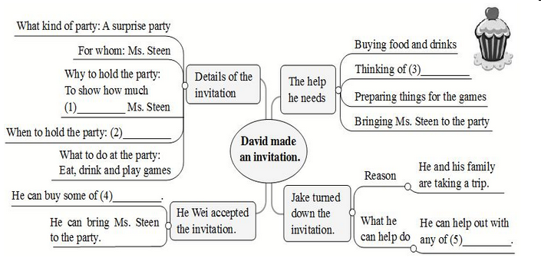

5. Work on 2c.

1) What kind of party is it?

_____________________________

2) Who is the party for?

_____________________________

3) When is the party?

_____________________________

4) Who did David invite to the party?

_____________________________

5) What can people do at the party?

_____________________________

**III. Writing**

Learn: How to make an invitation

How to accept / turn down an invitation

**IV. Work on 2d**

We are planning a housewarming _______ at our new house this Saturday. Can

you _______? Our house is at 2 London Road. We are serving _______ and

________ from 7:30 p.m. Please _______ your friends and family. A party is

more _______ with more people! Please let us _______ by Wednesday

_______ you can come to the party. Hope you can make it!

**V. Language points**

1. turn down an invitation

turn down把……调低；关小；拒绝

e.g. Please turn down the TV. It’s noisy.

He asked her for some help but she turned him down.

【链接】

同义词refuse, refuse to do sth. 拒绝做某事

turn on 打开 turn off 关掉 turn up 把……调高

【运用】完成句子。

1) Linda is studying. Can you ________ ________ (调低) the TV a little?

2) When they ________ ________ ________ (拒绝离开), we had to call the police.

3) ________ ________ ________ ________ (把收音机音量调大) so that everyone can hear.

4) He invited Suzy to the concert, but she ________ ________ ________(拒绝了

他).

Keys：1) turn down 2) refused to lave 3) Turn the radio up / Turn up the radio

4) turned him down

2. reply

reply作动词：

1) 作不及物动词, 后接宾语时, 需借助介词to。

2) 作及物动词, 一般接that从句等。

reply作名词时: 其后跟介词to，表示“对……的答复”。

get / have / receive a reply (to ...) 收到(……的)回复

give / make a reply (to ...) (对……)进行回复

【运用】完成句子。

1) 请对我的问题进行回复。

Please _______ _______ _______ _______ my question.

2) 他儿子没有给他回信。

His son didn’t _______ _______ his letter.

3) 她回复说她很忙。

She _______ _______ she was very busy.

Keys: 1) give/ make a reply to 2) reply to 3) replied that

3. However, I’d still be glad to help out with any of the party preparations.

不过, 我很乐意帮忙, 为聚会做些准备。

help (...) out (帮助……)分担工作、解决难题

help out可单独使用, 也可用于以下结构： help out sb. 和 help sb. out。

e.g. Do you need anyone to help out in the shop?

I was glad to help out a friend.

I agreed to help you out tonight.

4. Bring Ms. Steen to the party without telling her so that she can be surprised.

将蒂恩小姐带到欢送会，但事先不告诉她，这样她才能感到惊喜。

without是一个介词，意为“没有；不”后面可接名词、代词或动词-ing形式。

e.g. Without air, the plants will die.

Breakfast is important. We shouldn’t go to school or work without it.

Jack came into the house without knocking at the door.

【语境应用】请根据汉语意思完成英语句子，每空一词。

1) 没有伞你会淋湿的。

You’ll get wet __________ __________ __________.

2) 妈妈什么都没吃就匆忙去上班了。

Mom hurried to work __________ __________ anything.

3) 鱼没有水不能活。

Fish can not live __________ __________.

4) 没有你和她我睡不着觉。

I can’t fall asleep __________ __________ and __________.

Keys: 1) without an umbrella 2) without eating 3) without water

4) without you; her

so that 以便；以为是，引导目的状语从句

e.g. He spoke in a loud voice so that everyone could hear him.

Mike studies very hard so that he can catch up with Jake.

【语境应用】请根据汉语意思完成英语句子，每空一词。

为了上学不迟到，汤姆今天早上出发得很早。

Tom started out early this morning ________ ________ he wouldn’t be late for school.

Key: so that

5. I look forward to hearing from you all.

期待你们大家的回信。

look forward to 期待；期盼

后跟名词(短语)、代词或动词-ing形式

e.g. I look forward to your reply.

我期待你的答复。

I’m really looking forward to seeing my friend again.

我好期待再次见到我的朋友。

look短语：

look at 看

look around 环顾; 向四周看

look like 看起来像

look for 寻找; 寻求

look after 照料; 照顾

【运用】选词填空。

|  |
| --- |
| look around, look forward to, look like, look at, look for, look after |

1) I’m _________________ hearing from you soon.

2) He _________________ his new dictionary here and there, but he couldn’t find it.

3) —What does your brother _________________?

—He is tall and thin with brown hair.

4) Susan ________________ us very well. She is an excellent teacher.

5) We’d like you to ________________ and tell us if anything is missing.

6) Come here and ________________ these two pictures and tell me the difference between them.

Keys: 1) look forward to 2) looked for 3) look like 4) looked / looks after

5) looked around 6) look at

6**.** Hope you can make it!

make it是一个独立的表达方式，表示通过努力或经历困难后取得成功，完成某事，可译作“成功；胜利”，但有时也要视语境及上下文灵活选用合理的词语进行翻译，此处便是如此。又如：

If we run, we should make it.

要是我们跑得话，应该不会迟到。

Though it was difficult, they still made it.

虽然很难，但他们依然成功了。

**VI. Pair work**

Work on 2e. Imagine one of your favorite teachers is leaving. Plan a party for him/her. Answer the questions.

1) Why is he/she one of your favorite teachers?

2) What do you want to say to her/ him?

3) When is the best time to have the party?

4) Where can you have the party?

5) What kind of food will there be?

6) What kind of drinks would you like to serve?

7) Who will come to the party?

8) What activities will there be at the party?

9) How can you make the party a surprise for your teacher?

**VII. Summary**

___________ 去旅行

___________ 提高我的英语

___________ 做某事的最佳方式

__________ (帮助……)分担工作、解决难题

__________ 到目前为止

___________ 认为；想起

___________ 举办一场惊喜聚会

____________ 到这周五前

___________ 盼望 / 期待做某事

___________ 接到(某人的)信、电话等

___________ 回复邀请

___________ 拒绝

**VIII. Exercises**

**Ⅰ. 根据句意及所给首字母提示，补全所缺单词。**

1. He drove away w saying goodbye.

2. I’m g to hear you’re feeling better.

3. I asked him what he did last night, but he didn’t r .

4. David never turns down an i to dinner.

5. I’m really s that he remembered my birthday.

**Ⅱ. 根据句意，从方框中选择恰当的单词填空，注意形式变化。**

|  |
| --- |
| daytime, delete, calendar, sad |

1. Please _________ the first sentence (句子) because it’s meaningless.

2. Koalas sleep in the _________ and wake up to eat at night.

3. John is _________ because his cat died yesterday.

4. According to (根据) the _________, my birthday falls on a Sunday this year.

**Ⅲ. 根据汉语意思，完成英语句子，每空一词。**

1. 我很期待你下周的到访。

I’m really _______ _______ _______ your visit next week.

2. Cindy和她的朋友们上个月去马来西亚旅行了。

Cindy _______ _______ _______ to Malaysia with her friends last month.

3. Ted叫我和他出去吃饭，但是我拒绝了他。

Ted asked me to eat out with him, but I _______ _______ _______.

4. Paul每个月都会收到他姐姐的信。

Paul _______ _______ his sister every month.

**IX Homework**

Write an invitation according to 2e.

**Section B 3 (3a-Self Check)**

一、**教学目标：**

1.1) 掌握下列生词: opening, concert, headmaster, event, guest, calendar, daytime

2) 复习邀请信的表达方式，阅读相关邀请信并能获得相关信息，回答相关问题。

3) 能够综合运用所掌握的知识并根据相关提示来完成写一个简单的邀请信的任务。

4) 通过写一个邀请信及答复伙伴的邀请信，达到综合运用所学知识的目的。

5）复习本单元所学的重难点内容，及时巩固提高。

**2.** 学会人际交往的基本常识，学会有礼貌地邀请别人以及回答别人的邀请的方式。

二、**教学重难点**

1. 教学重点：

1) 复习邀请信的表达方式，阅读相关邀请信并能获得相关信息，回答相关问题。

2）能够综合运用所掌握的知识并根据相关提示来完成写一个简单的邀请信的任务。

3）复习本单元所学的重点知识点，并完成相关复习任务。

2. 教学难点：

通过写一个邀请信及答复伙伴的邀请信，达到综合运用所学知识的目的。

**三、教学步骤**

**Ⅰ. Reading**

1. Read the invitation and find the important information:

Time, Place, Activities

2. Work on 3a.

Read again and answer the questions.

1) Who is making the invitation?

2) What is the invitation for?

3) When will the event happen?

4) What will happen after this?

5) Do parents have to bring anything?

6) How should people reply to this invitation, and when?

阅读指导：

首先，阅读短文，整体把握短文大意。

其次，阅读后面的六个问题，明确问题的意思。带着这六个问题再去仔细阅读邀请信，在短文的相关位置找到这些问题的答案依据，并写出正确的答案。

最后，再通读一遍短文，结合短文内容检查答案有无错误或不周全的地方。

Ss try to read the article and try to fill in the blanks.

Check the answers with the Ss.

**II. Learning**

如何写正式的书面邀请函

如何回复邀请函

**III. Writing**

Work on 3b.

1. Think about a party or any other event you know. Write an invitation to your friends to come to your party or event.

2. Let some Ss read the information in the chart.

Include the following information：

kind of party or event

when and where it will be

if guests should bring anything

if guests should reply to the invitation

when and how guests should reply

Use the following words and phrases:

would like to, will be, after this, please, reply

3. 写作指导：

**【写作任务】**

假如你是李华，你刚刚搬了新家，为了庆祝乔迁之喜，你准备举办一个派对，你想邀请你的好友Karen来参加，请给她发一封邮件邀请她参加。

**【审清题目】**

**内容：**邀请某人参加派对

**文体：**应用文(邮件)

**时态：**一般现在时和一般将来时

**人称：**第一人称和第二人称

**【头脑风暴】**

|  |  |
| --- | --- |
| To whom | Karen |
| For what | Housewarming party |
| When (date and time) | ... |
| Where (place) | ... |
| Other information | roles to play, things to bring or clothes to wear |
| Ask for reply | ... |

**【提供素材】**

**◆句型**

**发出邀请：**

I would like to invite you to my housewarming party.

Can / Will you come to my housewarming party?

Please join us for a housewarming party to celebrate our new home.

Join us for some drinks at our new house.

We are happy to invite you to join us for a housewarming party.

Relax in our new great room and dance.

**聚会活动：**

Please bring ...             You don’t need to bring ...

We will / are going to ...     We can ...

**邀请回复：**

Please reply to me by Monday.

Please let me know if you can come to the party.

**表达诚意：**

Hope you can make it.

I do hope you can make it.

I look forward to meeting you.

**【谋篇布局】**

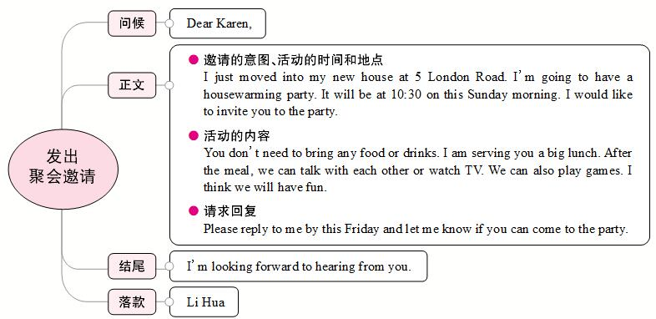

**IV. Pair work**

1. Read the calendar in 4. Make sure Ss know the activities in each day.

2. Tell Ss how to do it. Sa, look at your calendar on the right. Sb, look at yours on page 81. Find a time when you can both go shopping.

3. Model:

Sa: Can you go shopping with me next week?

Sb: Sure. I’d love to. When?

Sa: Well, what are you going to do on Monday evening?

Sb: I must study for English test. What about Tuesday evening?

4. Ss try to make some conversations.

**V. Self Check**

1. Work on 1.

Fill in the blanks in the conversation.

A: Hi, Peter. ______ you come to my party ______ the weekend?

B: Sure, ______ love to.

A: How about ______, Jenny?

C: I’m afraid I ______. I ______ to look after my little cousin.

A: _____ you come, Jeff?

D: I ______ be able to, but I’m not sure. _____ let you know tomorrow.

2. Work on 2.

Let Ss know how to write a refusal and a reason.

1) Invitation: “Can you come to my party on Saturday?”

Reply: ________________________

2) Invitation: “Let’s go to the movies tomorrow night.”

Reply: ________________________

3) Invitation: “Let’s go to the concert on the weekend.”

Reply: ________________________

4) Invitation: “Do you want to go shopping with me next week?”

Reply: ________________________

5) Invitation: “Can you play soccer with me after school today?”

Reply: ________________________

**VI. Exercises**

**根据短文内容，从方框中选择恰当的词语填空，有的需要变换形式。**

|  |
| --- |
| sad, invite, until, take a trip, available, reply, look forward to |

Emily is an English girl. It will be her fifteenth birthday the day after tomorrow. She is going to have a birthday party at her house that evening. Now she (1)________ some of her closest friends to her party by WeChat. She (2)________ having fun with them at the party. But Mary (3)________ that she can't come because she has to stay at home and do her homework. She won't finish it (4)________ 10:30 p.m. Luke can't come, either. He must go to the dentist (牙医) after school. Linda is not (5)________. Her parents will (6)________ to New York. They need to do some shopping. So Linda has to stay at home to look after her little sister. Paul would like to come, but he has to meet his friend from Canada that evening. Emily feels (7)________ about that. Everyone is busy! Finally, Emily decides to spend her fifteenth birthday with her family.

**VII. Homework**

According to the invitation in 3b, write a reply to your partner’s invitation. If you turn down the invitation, give a good reason.